Cell Disruption
Microorganisms are protected by extremely tough cell walls. In order to release their cellular contents a number of methods for cell disintegration have been developed. Any potential method of disruption must ensure that labile materials are not denatured by the process or hydrolysed by enzymes present in the cell. Huang et al. (1991) report the use of a combination of different techniques to release products from specific locations within yeast cells. In this way the desired product can be obtained with minimum contamination. Although many techniques are available which are satisfactory at laboratory scale, only a limited number have been proved to be suitable for large-scale applications, particularly for intracellular enzyme extraction. Containment of cells can be difficult or costly to achieve in many of the methods described below and thus containment requirements will strongly influence process choice.
Methods available fall into two major categories:
Physico-mechanical methods
(a) Liquid shear.
(b) Solid shear.
(c) Agitation with abrasives.
(d) Freeze-thawing.
(e) Ultrasonication.

Chemical methods
(a) Detergents.
(b) Osmotic shock.
(c) Alkali treatment.
(d) Enzyme treatment.
Physico mechanical method
- Liquid shear
Liquid shear is the method which has been widely used in large scale enzyme purification procedures. High-pressure homogenizers used in the processing of milk and other products in the food industry have proved to be very effective for microbial cell disruption.
One machine, the APV- manton Gaulin-homogenizer (The APV Co. Ltd, crawley. Surrey, U.K.), which is a high-pressure positive displacement pump, incorporates an adjustable valve with a restricted orifice (Fig. 10.21). The cells then pass through a narrow channel between the valve and an impact ring followed by a sudden pressure drop at the exit to the narrow orifice. The large pressure drop across the valve is believed to cause cavitation in the slurry and the shock waves so produced disrupt the cells. Brookman (1974) considered the size of the pressure drop to be very important in achieving effective disruption, and as with all mechanical methods, cell size and shape influence ease of disruption (Wase and Patel, 1985).
Darbyshire (1981) has stressed the need for cooling the slurry to between 0 and 4°C to minimize loss in enzyme activity because of heat generation during the process. The increase in slurry temperature is approximately proportional to the pressure drop across the valve. Because of problems caused by heat generation and because cell suspensions can be surprisingly abrasive, it is common practice to operate such homogenizers in a multi-pass mode but at a lower pressure. The degree of disruption and consequently the amount of protein released will influence the ease of subsequent separation of the product from the cell debris in high-pressure homogenizers and bead mills (Agerkvist and Enfors, 1990). A careful balance must therefore be made between percentage release ofproduct and the difficulty and cost of further product purification.
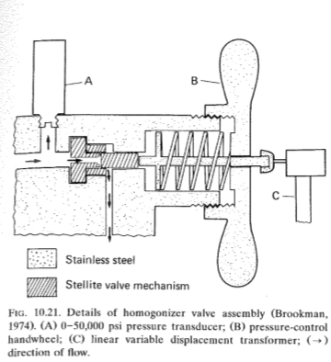

- Solid shear
Pressure extrusion of frozen micro-organisms at around - 25ºC through a small orifice is a well established technique at a laboratory scale using a Hughes press or an X-press to obtain small samples of enzymes or microbial cell walls. Disruption is due to a combination of liquid shear through a narrow orifice and the presence of ice crystals. This technique might be ideal for microbial products which are very temperature labile.
- Agitation with abrasives
Mechanical cell disruption can also be achieved in a disintegrator containing a series of rotating discs and a charge of small beads. The beads are made of mechanically resistant materials such as glass, alumina ceramics and some titanium compounds (Fig. 10.22).
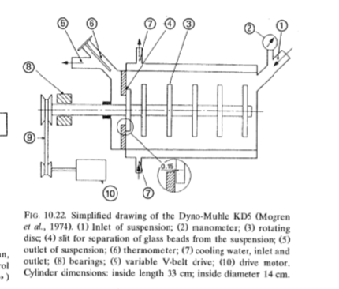
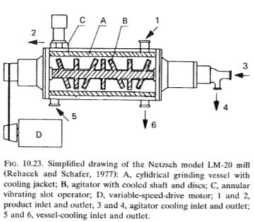
In a small disintegrator, the Dyno-Muhle KD5 (Wiley A. Bachofen, Basle, Switzerland), using a flow rate of 180 dm3 h-1, 85% disintegration of an 11% w/v suspension of S. cerevisiae was achieved with a single pass (Mogren et a!., 1974). Although temperatures of up to 35°C were recorded in the disintegrator, the specific enzyme activities were not considered to be very different from values obtained by other techniques. Dissipation of heat generated in the mill is one of the major problems in scale up, though this can generally be overcome with the provision of a cooling jacket. In another disintegrator, the Netsch LM20 mill (Netzsch GmbH, Selb, Germany), the agitator blades were alternately mounted vertically and obliquely on the horizontal shaft (Fig. 10.23). A flow rate of up to 400 dm3 h- 1 was claimed for a vessel with a nominal capacity of 20 dm3 (Rehacek and Schaefer, 1977).

- Freezing-thawing
Freezing and thawing of a microbial cell paste will inevitably cause ice crystals to form and their expansion followed by thawing will lead to some subsequent disruption of cells. It is slow, with limited release of cellular materials, and has not often been used as a technique on its own, although it is often used in combination with other techniques.
β-Glucosidase has been obtained from S. cerevisiae by this method . A sample of 360 g of frozen yeast paste was thawed at 50 for 10 hours. This cycle was repeated twice before further processing.
- Ultrasonication
High frequency vibration (- 20 kHz) at the tip of an ultrasonication probe leads to cavitation, and shock waves thus produced cause cell disruption. The method can be very effective on a small scale, but a number of serious drawbacks make it unsuitable for large-scale operations. Power requirements are high, there is a large heating effect so cooling is needed, the probes have a short working life and are only effective over a short range. Continuous laboratory sonicators with hold-up volumes of around 10 cm3 have been shown to be effective.
References
- Stanbury, The Recovery and Purification of Fermentation Products, Principles of Fermentation Technology, Second Edition.

